

Faith Lutheran Church Newsletter – April 2024

# LWML Meeting and Mite Boxes:

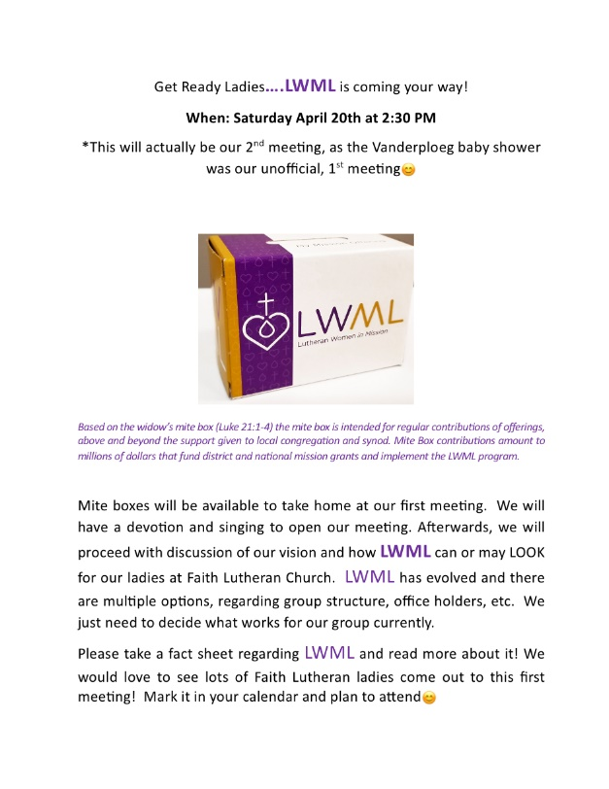

The LWML group will meet at the church on April 20 at 2:30 pm. There is an informational packet available at the church on the table under the bulletin board. Please contact [Kami Hoover](mailto:kamijohoover@gmail.com) for more information.

# Prayer List:

***Please keep these people in your prayers:***

**Barb Smith Gordy Schnarrs Monica Hupp Sandie Heidenway & Family**

**Bruce Meyer Jim Elliott Nancy Knief Sharon Hoover**

**Cathy Crump Jo Ann Chovan Ray Hauer Will & Lori Conners**

**Estelle Lyons LindaLou Stockinger Ruth Worshik**

***We also pray for others whose concerns we carry upon our hearts.***

# April Events:



Faith Lutheran Church Newsletter Page 2

**Weekly adult bible classes are offered both in-person and via Skype on Thursday mornings at 10 am (8 am class is in-person only at the church) and on Sunday mornings at 9:15 am. The 10 am Thursday class is held at** Brookdale Assisted Living, 910 Murfreesboro Road, Franklin, TN. We carpool after the 8 am class. So, if you would like to catch a ride with us, please be at the church before 9 am. Or you can meet us at Brookdale.

**Adult bible class:** <https://join.skype.com/HDUsNaV7Dt8c>

# Where to Find Us:

Church service times are Saturday at 5:00 PM and Sunday at 10:30 AM. Please join us!

We also live-stream our services simultaneously to both Facebook and YouTube most Sundays at 10:30 am. You can find us on our Facebook page entitled, **Faith Lutheran Church Thompsons Station, TN**at <https://www.facebook.com/faithlutherantn/>. When we are live streaming, you will see it show up in your notifications and in your newsfeed. You must **"Like"** our Facebook page in order for it to appear in your feed. The live feed on YouTube can be seen by subscribing to our YouTube channel at <https://www.youtube.com/channel/UCf6pYWhszns7n4ZJGnxqDdA>. You can also find the link to our YouTube videos on our website at [www.faithlutheran-tn.org](http://www.faithlutheran-tn.org/). Our sermon transcripts can be downloaded for your convenience from our website at: [Sermon Library - Faith Lutheran Church Thompsons Station, TN (faithlutheran-tn.org)](https://www.faithlutheran-tn.org/sermon-library-2024.html). Weekly bulletins can be found here: [Weekly Service Bulletins - Faith Lutheran Church Thompsons Station, TN (faithlutheran-tn.org)](https://www.faithlutheran-tn.org/weekly-service-bulletins-2024.html)

# Weekly Adult Bible Classes are Available via Skype and In-Person:

**The C. S. Lewis discussion group** will meet on Tuesday, April 16 at the Briggs’s home. Please contact [Pastor Curt](mailto:pastorcurthoover@gmail.com) for more information and the location.

**The Quilting Bee** will meet at the church on Wednesday, April 3 and 17 from 10 am-noon. Please join us for this time of fun and fellowship. Contact [Cathy DeWitt](mailto:crazy4horses@bright.net) for more information.

**Target Practice (From Craig Chovan):** Chip and Eve Fellows would like to invite everyone out to their home/property for a day of target shooting. This was an event that Ed and Pat McIntyre, Eve’s parents, had sponsored in the past and Chip would like to continue. The tentative dates are April 27th and May 4th. Everyone is welcome on April 27th, Chip’s thoughts were that the May 4th date would be more for the women if there is interest. Chip and Eve live in Lewisburg. Please RSVP to Chip or if you have any questions his number is 931-637-6939. Safety will be paramount. Chip will have a range laid out. As we get closer to the dates an update will be sent out.

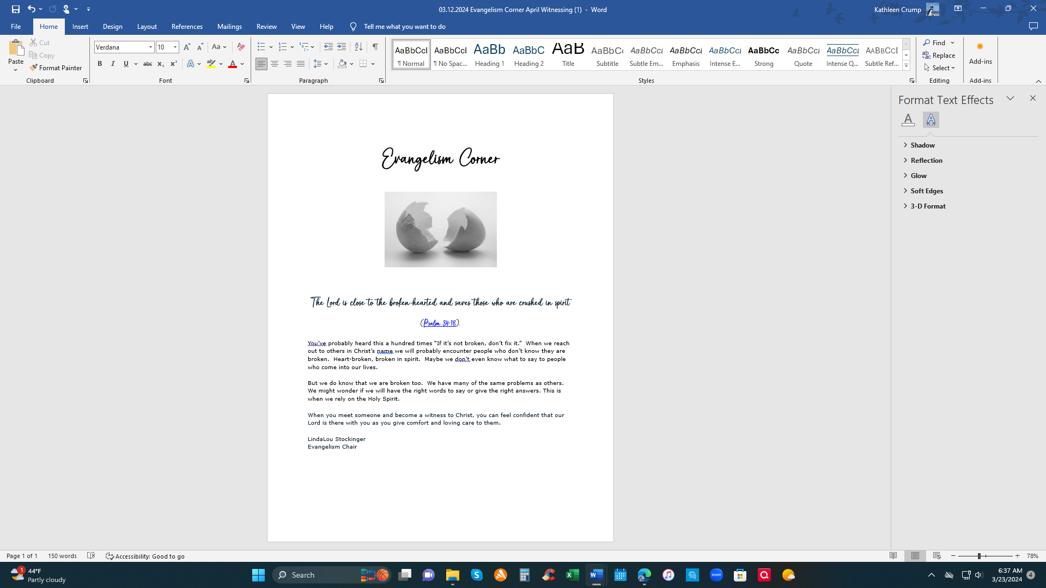

**Faith Lutheran Church**

**Rev. Curt Hoover, Rev. Alebachew Teshome,**

**Rev. Craig Fiebiger, Rev. Douglas DeWitt**

**2640 Buckner Road**

**Thompson's Station, TN 37179**

**Church Office: (615) 791-1880**

**www.faithlutheran-tn.org**

Faith Lutheran Church Newsletter Page 3