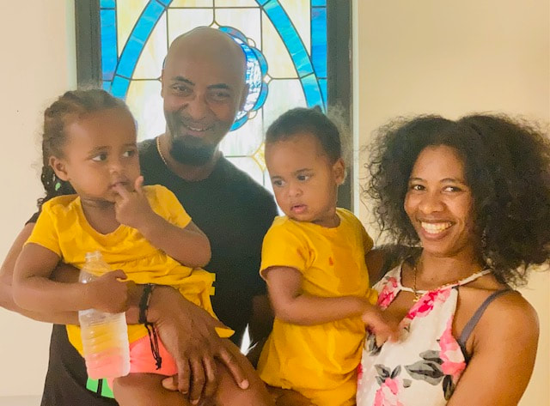

Supporting our Seminarian: Samuel Wondemu
Faith Lutheran Church is proud to announce that one of our own church family members, Samuel Wondemu, has been officially accepted to Concordia Seminary in Saint Louis. He just finished his first online class this week! He and his family will be moving to St Louis end of August so he can attend school fulltime. They will be living in campus family housing (address attached). Samuel has been an active member at Faith Lutheran Church (Ethiopian Ministry in Antioch) for several years. He has worked at Nissan for the last 9 years, since his arrival to USA in 2011. Prior to that, Samuel served in ministry in his home county, Ethiopia.
Samuel loves the Lord Jesus and is passionate about expanding God’s kingdom here on earth. We are blessed to have Samuel and his family as part of our family, here at Faith!
I want to reach out to all our members at Faith and ask that you support Samuel with your prayers, encouragement and with your monetary gifts. Not so long ago, Pastor and I were at the Seminary in Fort Wayne. We were very blessed (financially and emotionally) by our family congregation, along with other Lutheran Churches who adopted us. It was a huge help and lifted a burden from us; we are both very thankful for God’s care along the way.
Please consider helping Samuel and his family with this endeavor. Following are the costs to attend the Seminary:
- Tuition $28,800
- Campus Housing (family) $ 10, 500
- Health Insurance (single) $3792
- Books/supplies: $1185
Monetary gifts towards Samuel and his educational costs can be directed to:
Accounting Office, c/o Concordia Seminary, 801 Seminary Place, St. Louis, MO 63105. You can contact Laura Hemmer directly for more information at 314-505-7203 hemmerl@csl.edu
Below is more information about Samuel and his family. Keep him in your prayers, send them notes of encouragement and please, if able, support him financially in his mission.
Blessings in Christ Our Lord,
Kami Hoover 8/15/21
Samuel Wondemu Birthdate: August 10th Amaria (Spouse) Birthdate: March 14th
Samuel’s Mailing Address: 11 Founder’s Way, Unit B, St. Louis, MO 63105
Personal cell phone: 615-6491881 email: samwonde2017@gmail.com
Children: Eldana and Amen (identical twins, girls) DOB July 5, 2019. Currently, they are in size 3T.
Restaurants/Shopping: Kroger Grocery, Walmart, Ross and Target, Cracker Barrel, Olive Garden

